**Probability/Impact Matrix**

To determine the scores for probability and impact, we considered how directly each risk affects the project's main objective: the successful launch and operation of the NutriScope Health Tracker, targeting health-conscious individuals with innovative features like meal photo-based calorie estimation and wearable integration.

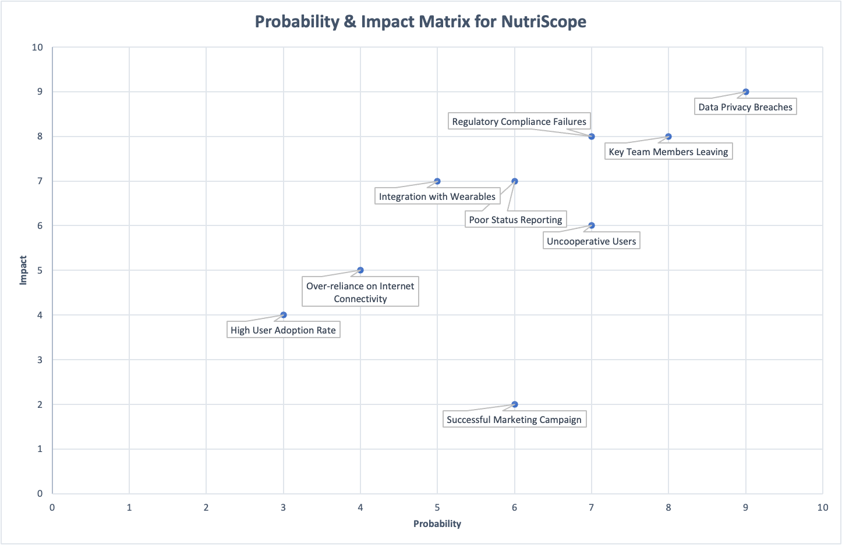

**Negative Risk: Data Privacy Breaches**

* **Probability (9/10):** Given the application's reliance on sensitive health data and the increasing prevalence of cyber-attacks, there's a high likelihood of potential breaches. The integration with various devices and platforms further complicates the security landscape.
* **Impact (9/10):** A breach would critically damage user trust, essential for a new application in a competitive market. Legal ramifications could lead to significant fines and mandate costly security overhauls. The high score reflects the severe consequences for project success, potentially derailing user adoption and tarnishing the brand.

**Positive Risk: High User Adoption Rate**

* **Probability (3/10):** While the team aims for a high adoption rate, such success in the initial stages is uncertain due to intense market competition and the unpredictability of user preferences. Thus, the likelihood is considered lower.
* **Impact (4/10):** A surge in users would validate the market need for the app and potentially increase revenue. However, it's rated moderately because, while positive, it also pressures the infrastructure and support systems, which could lead to challenges if not managed correctly. The app's scalability and customer service capabilities are untested at large scales, indicating a need for cautious optimism.

These scores reflect a strategic evaluation, emphasizing the criticality of safeguarding user data and the nuanced benefits and challenges of rapid growth. Balancing these factors is vital for guiding risk management and ensuring project resilience and success.

**Response Strategy for Data Privacy Breaches (Negative Risk):**

**Response Strategy:** Develop and implement a comprehensive cybersecurity strategy that encompasses state-of-the-art encryption technologies, deployment of a sophisticated intrusion detection system, periodic security audits by an external specialized firm, and a rigorous staff training program to foster a culture of security awareness.

**Specific Tasks and Execution Plan:**

1. **Enhanced Encryption Protocols:**
   * Task: Employ advanced encryption standards (AES) for data at rest and transport layer security (TLS) for data in transit.
   * Timeline: Procure and implement within 1 month.
   * Cost: Approximately $5,000 for software and encryption key management systems.
2. **Intrusion Detection System:**
   * Task: Install a network-based intrusion detection system (IDS) to monitor and analyze traffic for suspicious activities.
   * Timeline: Research, purchase, and implementation over 1 month.
   * Cost: Initial outlay of $10,000 for IDS software and hardware, plus ongoing maintenance.
3. **Periodic Security Audits:**
   * Task: Contract with a cybersecurity firm to conduct semi-annual audits to identify vulnerabilities.
   * Timeline: First audit within 2 months, then every 6 months.
   * Cost: Estimated $10,000 per audit.
4. **Employee Cybersecurity Training Program:**
   * Task: Develop an in-depth training curriculum on best practices for data handling and recognizing phishing and social engineering attacks.
   * Timeline: Curriculum development over 2 weeks, with quarterly training sessions.
   * Cost: Development costs of $3,000, with each session costing approximately $2,000.

**Response Strategy for High User Adoption Rate (Positive Risk):**

**Response Strategy:** Establish a scalable infrastructure to handle increased user loads effectively, including server elasticity, database optimization, and reinforced customer support. A systematic customer relationship management (CRM) system will be introduced to manage growing user interactions efficiently.

**Specific Tasks and Execution Plan:**

1. **Cloud Services Scaling:**
   * Task: Upgrade the current cloud services package to a more robust, elastic model that can handle increased loads.
   * Timeline: Negotiation and upgrade to be completed within 3 weeks.
   * Cost: Variable cost starting at an estimated $3,000 per month, adjusted based on user load.
2. **Customer Support Team Expansion:**
   * Task: Recruit, hire, and onboard new customer service representatives with expertise in tech support.
   * Timeline: Recruitment process of 2 months, with an additional month for onboarding and training.
   * Cost: Estimated $7,000 per new employee, including recruitment and training expenses.
3. **CRM System Deployment:**
   * Task: Select and deploy a CRM system for automation, ticketing, and user interaction tracking.
   * Timeline: Research and deployment phase spanning 2 months.
   * Cost: One-time setup fee of $10,000, plus a monthly subscription fee of $1,000.

These strategies incorporate a mix of upfront and ongoing investments to mitigate risks. They're aimed at fortifying the project against potential negative impacts while leveraging positive outcomes for sustained growth. Detailed planning and execution of these tasks are crucial for maintaining the project's integrity and success.